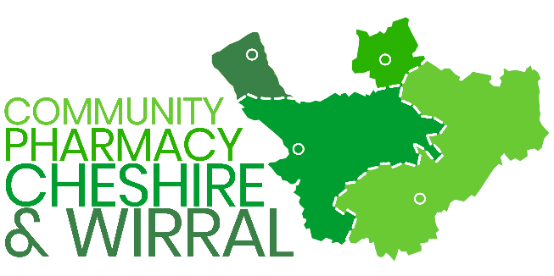 | SPECIAL MEETING OF CONTRACTORS  PROPOSED REVISED MODEL CONSTITUTION

Email and Postal Voting Form – Proposed Revised Model Constitution

Under the provisions of the LPC constitution contractors unable to attend the Special General Meeting may vote by email or post. To do so please complete this form ensuring that it reaches the returning officer by 12.15pm on Monday 7 September 2026. Email and postal votes received by that time will be added to the votes cast at the Special General Meeting.

Casting your vote: Please tick one option only

To help you make your choice, see https://cpcw.org.uk/about-us/constitution/

No amendments can be proposed to the new constitution either on this voting form or at the special meeting. If you do not accept the changes recommended by your LPC please try to attend the special meeting rather than voting in advance.

I approve the revised constitution
I do not approve the revised constitution
I plan to attend the special general meeting to discuss the revised constitution to cast my vote in person/online

About your Vote

One vote will be permitted per pharmacy premises (i.e. one vote per NHS ODS code) in the LPC area

Contractor Name/Trading Name
Number of Premise and ODS code(s)
Address(es) and Postcode(s)

Declaration

I confirm that I am the pharmacy owner or authorised on their behalf to complete this form.

Signed
Print Name
Position
Date
Contact Information

Returning your Voting Form

Please return the voting form before 12.15pm on Monday 7 September 2026 to Alison Williams at alison@cpcw.org.uk or via CPCW, PO Box 318, Runcorn, WA7 9DA.

** YOU WILL ONLY BE ABLE TO CAST YOUR VOTE AT THE SPECIAL GENERAL MEETING AFTER THIS TIME **

