


Pharmacy Signposting - NHS Service Finder
The NHS Service Finder is a real-time directory that connects healthcare professionals with up-to-date information on local NHS services across England. Designed with efficiency in mind, it gives pharmacies instant access to essential details all in one place.
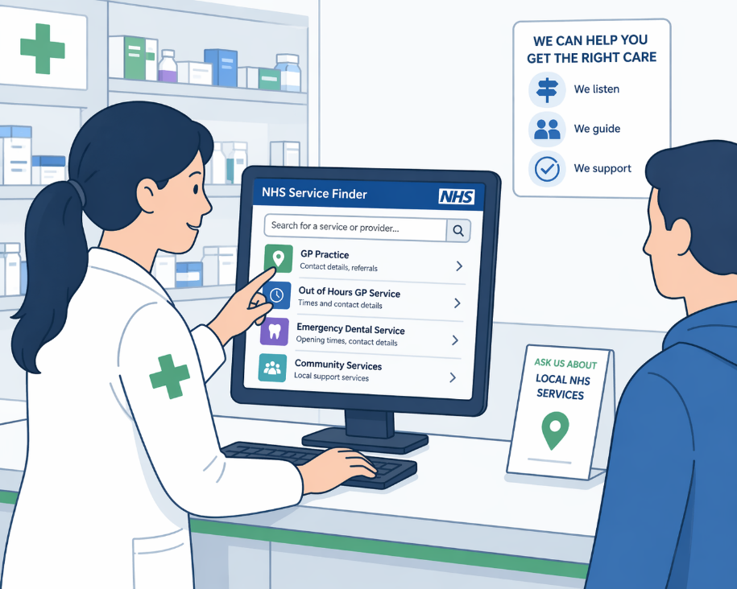
Pharmacy teams can access the NHS Service Finder through the NHS Service Finder platform. If you already have an active Smartcard you can log in with your Care Identity, alternatively if you don't have a Care Identity, you must create a Care Identity profile (opens in new tab). A Care Identity profile only takes a few minutes to create.
The directory holds a wide range of information including GP practices, urgent care centres, community services, mental health support, social care providers, and out-of-hours services such as GP out of hours, hubs, walk-in centres and emergency dental care. Crucially, it also includes non-public (not to be shared) contact numbers for GP practices and other services, enabling pharmacy teams to make direct referrals or escalate patient care quickly without relying on standard public lines.
The NHS Service Finder is an essential resource for effective signposting within the pharmacy, supporting safe, consistent patient advice across the whole team. It is important that all pharmacy staff are aware of the Service Finder, understand what it can do, and know how to access and use the platform confidently as part of their day-to-day roles.
Keeping information accurate is a shared responsibility. Pharmacy professionals are encouraged to report incorrect or outdated details - such as wrong phone numbers, opening times, or service changes - directly within the platform using the built-in report and feedback function. Updates are reviewed and actioned to maintain the integrity of the directory, ensuring that both patients and healthcare professionals have access to the most reliable and current information.
In short, the NHS Service Finder empowers pharmacies to deliver safer, smarter signposting - saving time, reducing pressure on services, and improving patient outcomes.

