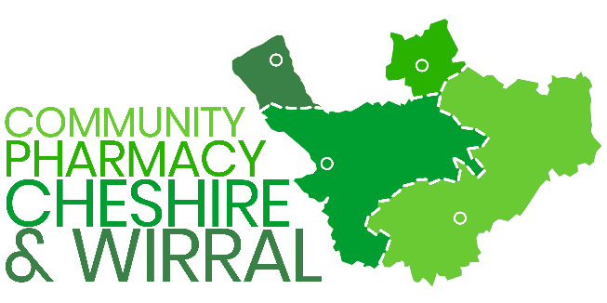 | NHS Directory of Services (DoS)  Geolocation

The NHS DoS is the live database that supports urgent and non-urgent care referrals. It provides clinicians and call handlers with real-time information on available services, including community pharmacies.

Each pharmacy entry contains a geolocation marker (map pin) linked to its address. This determines whether the pharmacy appears in electronic referral searches, based on proximity to the patient’s registered address or current location.

Accurate geolocation data within pharmacy DoS profiles is essential to:

- Ensure patients are offered the most appropriate and convenient pharmacy service.
- Maximise uptake of Pharmacy First and related referral pathways.
- Reduce inappropriate re-presentation to GP practices.
- Support pharmacy remuneration through correct service delivery.
Pharmacy Contractors

- Must ensure that their DoS profile, including geolocation, address, and service availability, is accurate and kept up to date and should regularly review their DoS entry to confirm accuracy.
Verification: Pharmacies should check their DoS profile regularly, to ensure accuracy confirming that the opening times, service provision and geolocation marker corresponds to the correct premises.

Correction: Any inaccuracies must be reported promptly to the regional DoS lead or NHS England commissioning team for amendment.

Ongoing Maintenance: Updates to opening hours, service provision, or relocation must be reflected in DoS without delay.

Before asking DoS to change the pin:

- Ensure address, name and opening hours are correct in NHS Profile Manager.
- If you have relocated or rebranded, ensure statutory records (eg, GPhC, ODS/NHSBSA, commissioning) have been updated or are in progress. (DoS can move the pin, but persistent address mismatches elsewhere can cause reversion or confusion.)

Email template to the DoS team

Subject: DoS Geolocation Correction Request – <Pharmacy Name, ODS>

Dear DoS Team

Please could you update the geolocation (map pin) for our pharmacy on the Directory of Services?

- Pharmacy: (Trading name)
- ODS code: (Code)
- GPhC premises Number: (Number)
- Address: (Full address, postcode)
- NHSmail:
- Issue summary: (eg Pin placed on adjacent street; pharmacy excluded from local referrals)
- Current DoS location or approximate location, if possible, apply a screenshot
- Correct location:
- Impact: [missed Pharmacy First referrals/patient access/safety]
- Attachments: Screenshots, evidence of relocation (if applicable), photograph on pharmacy front.
Please confirm when updated or advise if any further information is required.
Many thanks,

Your name

Once submitted you should receive a ticket/reference number to track the log. If you do not receive one, please ask for one.

If you have questions or need any further support, please contact sara@cpcw.org.uk

