14th March 2024

Dear Pharmacist / LPC

From 1st April 2024, Change Grow Live will take over the management and co-ordination of the pharmacy needle exchange and supervised consumption scheme. Payments for these services as of 1st April 2024 will be made by Change Grow Live.

From April 1st, 2024, we will:

- Invite pharmacies to an online engagement event with an opportunity to give feedback and ask questions. We will send out a prospective date over the coming weeks.
- Work with the LPC and Warrington Local Authority Commissioning team to develop the new pharmacy contracts.
- Discuss the new contract arrangements and finalise contract signing with the pharmacies involved.
To ensure a smooth transition, the terms of the existing agreements between Warrington Borough Council and the respective pharmacies will be honoured by CGL until 30th September 2024 or until new agreements are established (whichever is earlier)

We look forward to working with you over the coming months.

Kind Regards
David Bamford
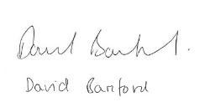
Director

Change Grow Live

