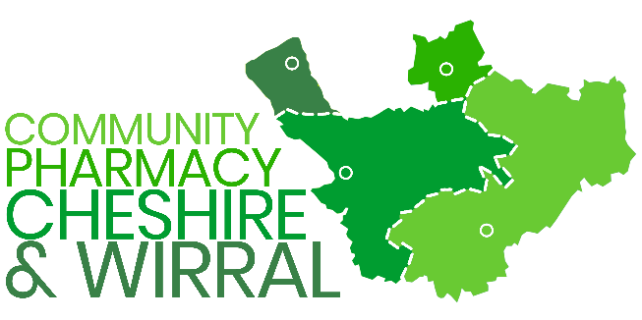 | PATIENT INFORMATION:  What to do if your pharmacy is closing

- Collect any outstanding prescriptions
If you have any prescriptions or medicines outstanding, you need to collect them from the pharmacy before the date they close.

You will not be able to collect any prescriptions left or owed to you after the pharmacy has closed.

- Changing your nominated pharmacy

You can change the pharmacy you have nominated to receive your electronic prescriptions whenever you want, easily and in several ways.
It is your choice which pharmacy you want to use and a list of all the pharmacies in your area can be found at https://www.nhs.uk/nhs-services/prescriptions-and-pharmacies/

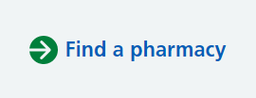

Options for changing your nominated pharmacy:
- You can go into the pharmacy you want to use in future and ask them to change your nomination, or
- If you have the NHS App you can login and change your nominated pharmacy yourself, or
- You can ask your GP surgery to change it for you
Once you have changed your nominated pharmacy all your future prescriptions will automatically be sent to that pharmacy.

Please be aware that the new pharmacy will not have any records of your previous medicines or prescriptions and so it will take time for them to build up that information.

