Useful Cheshire West Safeguarding Resources for Dentists, Optometrists and Community Pharmacists

Cheshire West and Chester Safeguarding Adults Board:
Local Safeguarding Adults Board (LSAB) | Cheshire West and Chester Council
Professional Area including training info: https://www.cheshirewestandchester.gov.uk/residents/health-and-social-care/adult-social-care/lsab/professional-area

Cheshire West and Chester Safeguarding Children Partnership
https://www.cheshirewestscp.co.uk/

Cheshire West and Chester Safeguarding Children Partnership Multi Agency Training https://www.cheshirewestscp.co.uk/training/

Cheshire West and Chester Safeguarding Adults Board run:
Domestic Violence and Abuse Awareness Course
https://www.cheshirewestandchester.gov.uk/residents/health-and-social-care/adult-social-care/lsab/training.aspx

Other Useful Safeguarding Resources

NHS England Safeguarding App
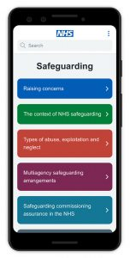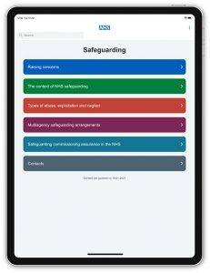
The NHS Safeguarding app has been developed to act as a comprehensive resource for healthcare professionals, carers and citizens. It provides 24-hour, mobile access on up to date legislation and guidance across the safeguarding life course.
The app also provides information on how to report a safeguarding concern and even has a directory of safeguarding contacts for every local authority in England, searchable by region.
It can be accessed via Apple iOS, Google Play or it can be downloaded by visiting your device’s appropriate app store and searching for ‘NHS Safeguarding’.

Virtual College free online Courses:
- Forced Marriage awareness course https://www.virtual-college.co.uk/resources/free-courses/awareness-of-forced-marriage

- FGM Awareness
https://www.virtual-college.co.uk/resources/free-courses/recognising-and-preventing-fgm

Health Education England Safeguarding Courses:

Useful courses can be found at Home - elearning for healthcare (e-lfh.org.uk)

HEE in association with the Institute of Health Visiting have developed an eLearning package on DVA intended for use by health visitors and nurses but useful for other professionals. The programme consists of four new modules

- Module one – Understanding domestic violence and abuse
- Module two – Identification of domestic violence and abuse
- Module three – Risk assessment for victims of domestic violence and abuse
- Module four – Safety planning and support for families

The modules include videos, case studies, links to aid learning and questions to test your knowledge of the subjects and reflect on your learning.
https://www.e-lfh.org.uk/programmes/domestic-violence-and-abuse-e-learning-for-health-visitors-and-nurses/

Health Education England Safeguarding Adults: Level 3 Training. 3 week online course with 1 hour of study per week. Course currently run every 8 weeks:
https://www.futurelearn.com/courses/level-3-safeguarding-adults

PREVENT
Prevent Awareness online training
https://www.elearning.prevent.homeoffice.gov.uk/edu/screen1.html
https://www.elearning.prevent.homeoffice.gov.uk/la2/screen1.html

